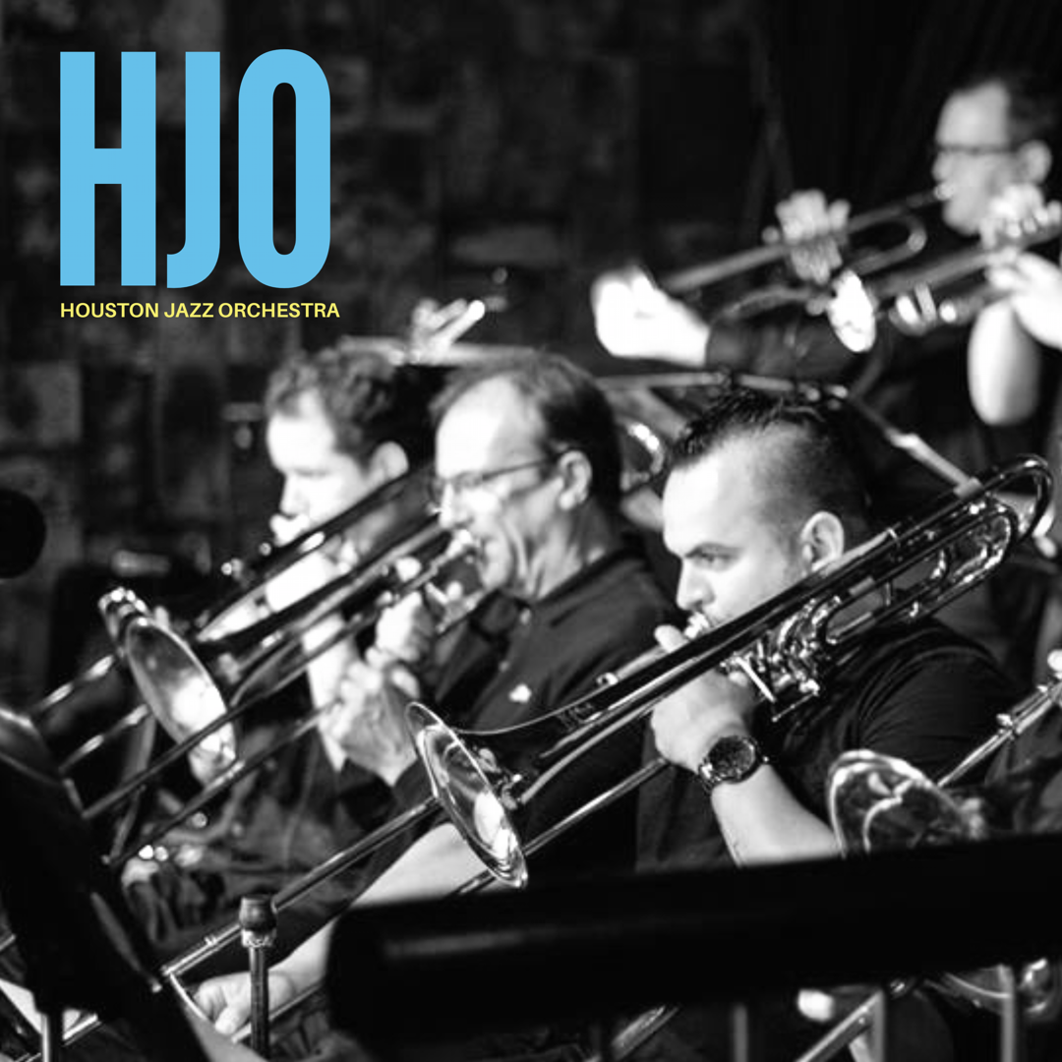
501(c)(3)

INTRODUCTION

The HJO was started and organized as a Texas nonprofit corporation in 1989. It has been in continuous existence during the past 28 years with occasional periods of inactivity. In October of 2016 the HJO qualified for exemption as a 501(c)(3) organization.
The vision of the HJO is to be accessible to students who are studying and learning to play jazz music by filling the void left by the demise of the legacy professional touring orchestras. In the decades of the 1970’s and 80’s there were many professional big band orchestras touring and performing regularly. The orchestras of leaders Stan Kenton, Woody Herman, Buddy Rich, and Maynard Ferguson had touring schedules with heavy emphasis on performing at colleges and high schools in addition to the typical venues of clubs, theaters, and jazz festivals. These performances fostered the burgeoning jazz education movement by targeting young audiences with performances and master classes in high schools and colleges. Moreover, these orchestras recruited talented musicians from colleges with jazz programs most notably North Texas, Berklee College of Music, and University of Miami.
With the deaths of Kenton, Herman, and Rich in the 1980’s and the subsequent death of Ferguson in 2006, there are very few professional jazz orchestras performing publically. Although jazz education is more prolific in school systems and colleges than ever, there are few opportunities for students to hear, see, and interact with a professional orchestra performing the music they are studying in school. By performing regularly at a public venue, and scheduling clinics at area schools, the HJO will fill the void.
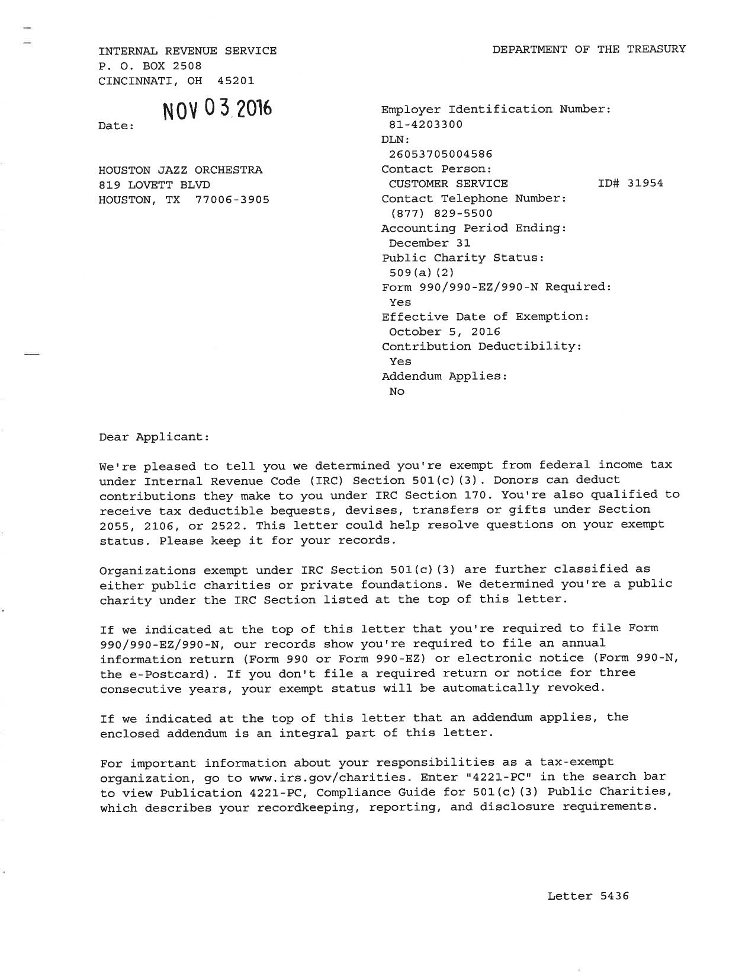
MISSION
To present and promote the appreciation of large ensemble jazz through live performance, recording, and educational outreach.
BOARD OF DIRECTORS
JAMES RYTTING
JOEL FULGHAM
THOMAS HULTEN

PRESIDENT
JIM McLAUGHLIN
As President of the HJO, Mr. McLaughlin is responsible for the business affairs of the organization.

PLAYER’S COMMITTEE
All artistic, operational, and administrative control of the HJO is by the Player’s Committee made up of five current musician members, one from each section (trumpets, trombones, woodwinds, and rhythm), plus a fifth member.
JOEL FULGHAM - rhythm
THOMAS HULTEN - trombones
WARREN SNEED - woodwinds
ROBBY YARBER - trumpets
JIM M cLAUGHLIN – fifth member

BIOS
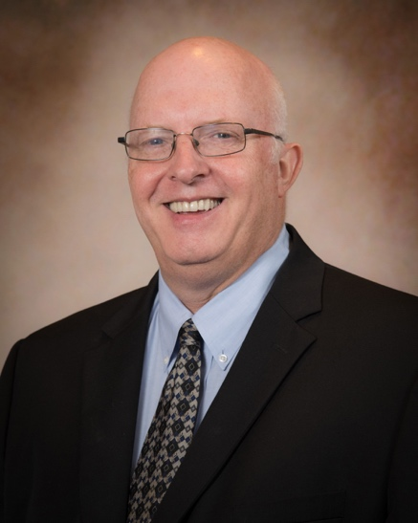 | Warren Sneed is the Director of Jazz Studies at Houston's High School for the Performing and Visual Arts (HSPVA). Sneed has a Master’s in Applied Music from University of Houston and a Bachelor’s in Jazz Education from University of North Texas, and is an HSPVA graduate. He previously taught at University of Houston and Houston Community College (Westchester Campus).
Sneed is active in the Houston jazz scene; and the Sneed Quartet, which includes his son, drummer Andrew Sneed, plays regularly at Houston’s Cezanne. Sneed’s performance credits include Louis Hayes, Ed Shaughnessy, Freddie Hubbard, Doc Cheatum, Kenny Wheeler, Carl Fontana, Rosemary Clooney, Bob Dorough, Roseanna Vitro, Todd Coolman, Jimmy Haslip, Mitch Watkins, Helen Sung, Bobby Shew, Dave Catney, Joe LoCascio, and Pamela York.

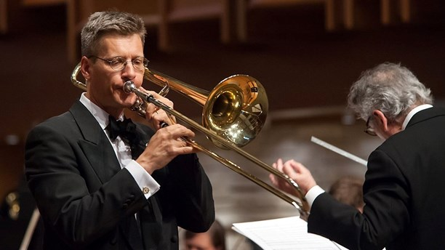 | Thomas Hultén, Principal trombone with the Houston Grand Opera and the Houston Ballet. After completing his military service with the Swedish Army Band, he studied with Ingemar Roos at the Gothenburg Conservatory.
After graduating he won a position with the Bohuslän Big Band, one of Sweden’s two professional full-time big bands. He has performed with several Scandinavian orchestras, including the Gothenburg Symphony, the Royal Swedish Opera, the Danish National Symphony and the Stavanger Symphony.
Since moving to Houston in 1997 he has performed with the Houston Symphony, the San Antonio Symphony and artists such as Ray Charles, Tony Bennett, Dave Brubeck, Natalie Cole, Barry Manilow, Patti Austin, Johnny Mathis, Chaka Khan, and Michael Bolton.
Thomas has played in the orchestra for several touring Broadway musicals, like “Lion King” and “Wicked”.
He has been featured at the International Trombone Festival and has toured Europe, Japan, Australia and New Zealand.
Thomas is a member of the River Oaks Chamber Orchestra (ROCO). With ROCO he premiered Dorothy Gates’ trombone concerto “Servant of Peace” in 2016.

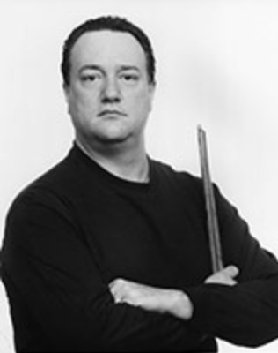 | Joel Fulgham is a graduate of the High School for the Performing and Visual Arts (HSPVA) and attended the University of North Texas where he performed with the One O’Clock Lab Band. He has over 35 years of professional playing experience and performs regularly with
The Houston Symphony pops series, Theater Under the Stars, numerous musical groups in the region, and is in high demand for recording sessions and concerts. He has performed with Bob Hope, The Smothers Brothers, Andy Williams, Freddy Hubbard, Bill Watrous, Joe Henderson, George Coleman, Michael Brecker, Arnett Cobb, and leads his own jazz group Monstrosity. Mr. Fulgham is a member of the faculty at the Moores School of Music at University of Houston.

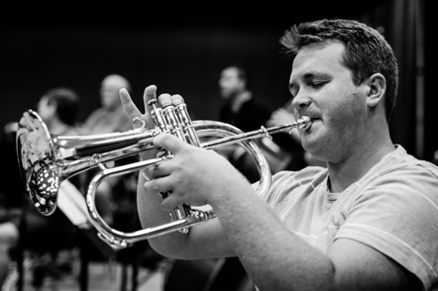 | Robby Yarber is a graduate of Sam Houston State University and a former student of The University of North Texas, where he was a member the One O’ Clock Lab Band. He performed with the Disneyland
All-American College Band and the world famous Glenn Miller Orchestra. He has performed with some of the most renowned musicians in the world including Wayne Bergeron, Wycliff Gordon, Tom Malone, Frank Greene, Bobby Shew, Gordon Goodwin, Sal Lazano, and Bill Watrous.
In addition to being a freelance trumpeter, Mr. Yarber is the band director at Cryar Intermediate School, and teaches private lessons and masterclasses.
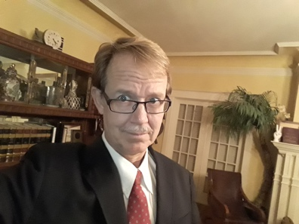 | James G. Rytting is a criminal attorney and an associate with the law firm of Hilder & Associates, P.C. specializing in U.S. Constitutional challenges and criminal appeals. Mr. Rytting earned a Bachelor of Arts degree from Cornell
University, and Master of Arts degree from Indiana University. Following a university teaching career, Mr. Rytting graduated from the University of Houston Law Center.
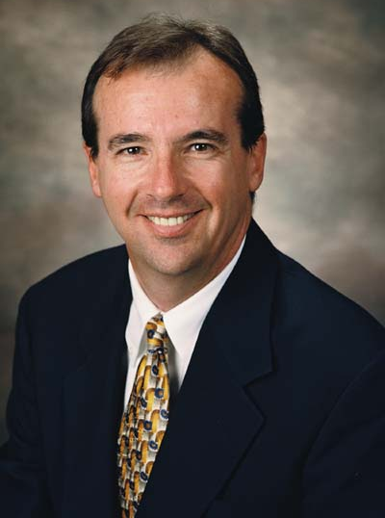 | Jim McLaughlin has been a professional trombone player for over 45 years. He has a Bachelor of Music in Jazz from University of North Texas. Following graduation from North Texas he performed with numerous house orchestras in Las Vegas until relocating to Houston in 1982.
Mr. McLaughlin played trombone with the Danny Ward Ensemble for 20 years and lead trombone with the Ed Gerlach Orchestra for over 30 years. He has played with numerous orchestras performing with entertainers such as Burt Bachrach, Sammy Davis Jr., Bob Hope, Diana Ross, Cher, Jerry Lewis, Lyle Lovett, Andy Williams, Glen Campbell, Roy Clark, Doc Seversen, and Tony Bennett.
Mr. McLaughlin also holds an MBA in Business Management from University of Dallas and has over 35 years’ experience in commercial real estate development and consulting to Fortune 500 corporations. Currently a member of CapRidge Partners of Austin, Mr. McLaughlin was formerly Senior Managing Director at Newmark Grubb Knight Frank in Houston, and a Managing Director with CBRE / Trammell Crow Company for 15 years.

Budget
Educational Outreach

Clinics with Master Classes (includes one hour concert)
A school clinic and master class consists of afternoon class sessions conducted by members of the HJO and culminate with a rehearsal and evening performance featuring the student orchestras prior to the HJO concert performance. Our goal is to do twice a year, fall and spring.
Curriculum
Class I - HJO section leaders and featured jazz soloists conduct rehearsal of student jazz orchestras with HJO members sitting in the band with the students. 1 hr. x 8 HJO members $50 ea. | $ 400
Class II - Conduct four sectional master classes 1 hr. x 8 HJO members $50 ea. | $ 400
Class III - Full HJO rehearsal with student orchestras and evening concert performance. | $3400
Performance material (allowance) | $ 400
Per diem expenses | $ 200
TOTAL | $4800

Music Library
The music performed by the HJO is purchased by the individual members. The cost of published arrangements ranges from $45 to $100 each. The HJO would like to commission original music composed specifically for the HJO. Estimated cost for one piece is $1,500-$3,000.
Equipment
The HJO relies on the generosity of others to borrow pianos for performances. The HJO would like to purchase a keyboard of its own to use for performances. Estimated cost is $1,000-$2,000.

Performances
Public Performances
The HJO has a collective bargaining agreement with the local Houston Professional Musicians Association (Local 65-699 A.F.M) allowing the HJO to perform on “off nights” such as Monday or Tuesday at venues less than 400 seats, provided there is no cover charge or admission fee and no dancing allowed.
The reduced pay scale is for no less than $50 per musician, plus required work dues to the Union and pension benefit contribution. A performance cost totals $1,018.

January 20, 2018 Region 9 All-region Clinic
Students participating in the All-region jazz ensembles have won live auditions and are the best of the region.
The process starts in May of each year when the audition pieces are published. Students practice their three audition pieces during the summer and perform them in September at a live audition in front of a panel of judges. All auditions are ranked in numerical order, and the top four on each instrument selected for two All-region jazz ensembles.
At the same time, some of the finalists are subsequently selected to record their audition for submittal to the All-state panel of judges. The judges are a secret panel who meet in November to select the finalists from all auditions submitted from the entire State. The All-state performances are during the Texas Music Educators Association (TMEA) annual conference in February.

House of Blues
The public performances of the HJO at the House of Blues are compensated $600 on Monday nights for two 75 minute sets. Donations from the audience to the HJO are used to compensate for the payroll shortfall.
The venue seats 160 and provides lights, sound equipment, and a sound engineer at no cost to the band. The HJO Board and Player’s Committee feel that the venue is a good marketing opportunity for the band because it is family friendly, centrally located, and a brand that is known for music performance.

Financial Statement FY 2017
Assets
Grant | $ 2,500
Donations - cash | $ 1,238
Revenue from performances | $ 6,921
TOTAL | $10,659

Expenses
Wages | $ 6,840
Union Work Dues | $ 132
Pension Contribution | $ 69
Equipment & Music | $ 449
TOTAL | $ 7,490

Cash
Cash on hand | $ 3,169

